Lesson 1 Optional Activity: Slides and Vignette Materials

This page left intentionally blank.

Lesson 1 Optional Activity: Employee Engagement Vignettes
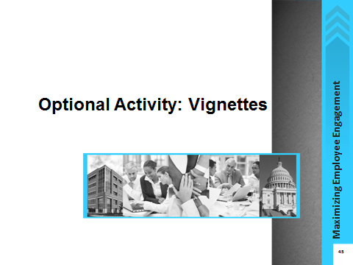
Notes:

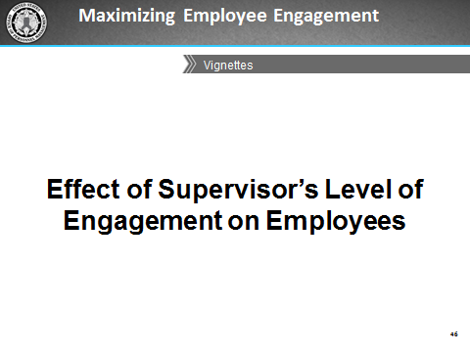
Notes:

This page left intentionally blank.

Vignette 1
Betty is a manager who loves her job and is very passionate about what she does and how she does it. She takes advantage of opportunities to learn more about her field, attending an annual conference and signing up for seminars when they are offered. Her personal values align well with those of the agency, and she emphasizes the importance of their mission to her staff. She ensures that her people are prepared to take advantage of developmental opportunities. Her staff always knows her expectations for their work because she meets with them regularly to discuss their work.
Her employees always give her their best and follow her lead in looking for opportunities to grow professionally. They take great pains with their work to ensure it’s the best they can do. They often collaborate with each other, reaching out to help each other achieve their goals.
Betty has never thought to nominate her team for the agency’s annual Outstanding Department of the Year award for exceptional performance, even though managers often tell her how much they enjoy working with her team. They often praise the team’s professionalism and say that the team’s work is first-rate. Betty takes great pride in receiving these compliments, as she believes it is because of the high standards she has instilled in the team.
Questions for discussion:
- On a scale of 1- 5, 1 being disengaged, 5 being highly engaged, how engaged do you think Betty is? What is the basis for your judgment?
- Betty is clearly very involved in her own work and expects her team to meet her high standards. What are some of the positive results of Betty's level of engagement in her job?
- How would your employees respond to Betty's style and level of engagement? Why?

Vignette 1 Notes
Instructions: Record the outcomes of your group’s discussion about the vignette questions in the space provided below.

Vignette 2
Sam was promoted to supervisor almost a year ago, partly because of his strong technical skills, but also because he so clearly loved what he was doing. His values closely matched the mission of the organization, which made him work harder than many of his counterparts. He is highly competent in his team’s technical area, and often prefers to solve problems himself rather than delegating appropriately to his employees or ask their opinions on how to proceed.
Although Sam is courteous and respectful to his staff, he does not spend much time talking with them to find out about their career goals or professional interests. He is very reserved and his team seems to be reluctant to initiate conversations with him about topics such as his expectations for their performance, opportunities for growth, or offering to take more responsibility for decision making.
Sam received feedback during his performance review that suggested he should focus on his interpersonal skills as a way to help his staff become more engaged with their work and the agency. Since he received this feedback, Sam has become less enthusiastic and involved in his work. He often leaves work early and avoids having one-on-one conversations with his team. He knows that this is having a negative effect on his team’s engagement and motivation, but he does not know what to do.
Questions for discussion:
- Sam was highly engaged at the time of his promotion, but the elements of his job that require supervision and one-on-one interaction with staff make him uncomfortable. As a result he is becoming less engaged. What effect will this have on his team's level of engagement?
- If you were Sam's manager and you noticed this change in behavior, what would you do?
- If Sam really wants to change things and get his team engaged in their work, what could he do?

Vignette 2 Notes
Instructions: Record the outcomes of your group’s discussion about the vignette questions in the space provided below.

Vignette 3
Francine is an experienced supervisor who absolutely loves her job. She enjoys both the technical work and, particularly, being in a position to assist and influence others in their career development. She feels that working with her team is one of the most important things she does, and looks forward to opportunities to mentor them and share her knowledge. Francine also acts as a conduit for information from other parts of the organization. Last month, her manager told her that several budget-cutting actions were coming within the next two months. These included cutting training classes and cuts in awards programs for the rest of the fiscal year. Depending on how much money is saved through these cuts, leadership is considering reorganizing some departments to improve efficiency.
Her staff seemed to appreciate her interest and they came to her for advice and, following her example, they worked very collaboratively. After she told her team about the upcoming budget cutting measures, she has noticed that they seem to be working more on their own rather than seeking out others to share ideas or discuss problems. In addition, they are not communicating with her in person, often choosing to email her rather than call or come to her office. So far, performance has not decreased, but Francine is concerned that the cuts are causing her team to feel less engaged with the agency.
Questions for discussion:
- What are some potential causes for the change within the team?
- What can Francine do to help improve the team’s engagement level?
- What effect might her staff’s lower levels of engagement have on Francine’s own attitude and engagement? What could she do to re-energize herself?

Vignette 3 Notes
Instructions: Record the outcomes of your group’s discussion about the vignette questions in the space provided below.

This page left intentionally blank.

Lesson 3 Optional Activity: Slides and Case Study Materials

This page left intentionally blank

Lesson 3 Optional Activity – Case Study
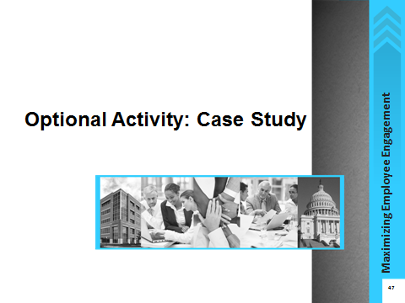
Notes:

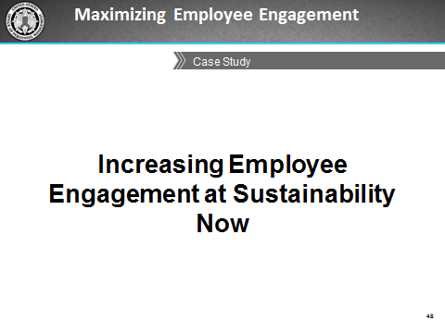
Notes:

Case Study
Sustaining Employee Engagement through Change
You are a supervisor at the non-profit think tank Sustainability Now (SN), whose goal is to advance research in the field of environmental sustainability. SN has been among the most highly respected organizations in its field. In the three decades of its existence, it has played a major role in changing the way government agencies, corporations, and individuals interact with their environment.
However, over the past five years, things have been changing at SN. While employees typically had very long tenures, now several people at all levels have left after just a few years. The recession resulted in reduced funding for research, and recently two new think tanks have cropped up in the same field, vying for scarce resources. Mid-level researchers are working long hours trying to win as many grants as they can from a smaller pool. Ratings on morale and supervision, as measured by the organization’s annual climate survey, have dropped considerably.
Recent exit interviews indicate frustration with bureaucracy. “The Executive Team approves every single grant application. It often takes up to a month to get permission to apply,” said one scientist who called it quits after seven years. “By the time we start working, it’s a scramble, and there isn’t enough time to develop an outstanding application.”
Talk at the cubicles is about who worked the longest over the weekend and whether there will finally be funds to hire someone to help relieve some of the workload. Water cooler conversations are dissolving into complaints that the annual bonus—the same amount for all employees—does not reward individual performance. Junior employees have a different complaint: that their supervisors are more interested in working on their own research than in ensuring that their employees get opportunities to apply their skills. You recently overheard one of your employees tell another, “I would love to take on a bigger role and lessen some of my boss’s workload—she is always stressed out. But she keeps putting off meetings I try to schedule to discuss my research interests or development. Those might help her see that I could help her directly. It just doesn’t seem important to her at all.”
On the other hand, benefits, especially the ability to telework and work flextime got high ratings from employees at all levels and tenures. Other human resource processes are well managed too. The internship and training program for entry-level scientists both get a lot of positive feedback and have applicants lining up for the entry-level jobs. But more than anything, it is the work itself that seems to be sustaining a lot of people in these turbulent times. “I love the research I do,” enthuses one employee. “It makes me feel I’m giving back to the environment, and that’s the most important thing for me.” This passion continues to show in the work that Sustainability Now does: last year, two senior researchers received national awards for their contribution to the field.

Questions for group discussion:
- What kinds of issues are going on at Sustainability Now that appear to be hindering employee engagement?
- What factors appear to support employee engagement?
- What types of factors are playing out among different groups of employees?
- As a supervisor at Sustainability Now, what actions would you take to improve employee engagement?

Case Study Notes
Instructions: Record the outcomes of your group’s discussion about the case study questions in the space provided below.

This page left intentionally blank

Job Aid: Other Government Agencies’ Strategies to Drive an Engaged Organizational Culture
Introduction
The following government agencies shared with OPM what they do to maximize employee engagement within their organizations:
- Department of Education (ED)
- Department of Human Services (DHS)
- National Aeronautics and Space Administration (NASA)
- National Institutes of Health (NIH)
- Nuclear Regulatory Commission (NRC)
- Office of Management and Budget (OMB)
- Office of Personnel Management (OPM)
- United States Coast Guard (USCG)
While not all of these will work within your agency because of the different organizational culture, you should still be able to find a few ideas that will be well-suited and relatively easy to adopt and practice within your team. Implementing these or similar ideas could have a positive influence on your agency's engagement levels, and ultimately, FEVS engagement scores.
Employees
Ideas involving Employees | What it looks like
Create a “Morale Committee” | Create a committee that develops and enacts ideas to make staff feel appreciated (e.g., promoting health and wellness activities, providing non-monetary rewards).
Recognize Other Staff | Encourage staff to nominate coworkers for good work. Employees select who wins the awards, which promotes a sense of pride by being nominated by their peers.
Practice the Servant Leadership Model | Focus on helping others and modeling good leadership.
Get Together Outside Work | Schedule activities such as bowling, happy hours, and movies to help bring teams together.

Supervisors and Managers
Activities Supervisors and Managers can do | What it looks like
Create Teambuilding Activities | Many offices hold division level retreats and seminars that include all divisional staff. These meetings typically focus on topics of interest to the division and often include segments that are used to identify ways to improve the operation of the organization.
Bring Food into the Equation | Supervisors or managers bring in food (e.g., pizza, cupcakes) for employees during group meetings. Managers take their staff out for lunch just because they want to; staff can see that the manager enjoys doing it and that it is authentic and not forced.
Develop and Monitor Individual Development Plans (IDPs) | As part of the performance process, employees and their supervisors discuss their IDPs. This includes discussing goals, performance expectations, and things they will do throughout the year.
Give Employees the Opportunity to Select their Own Assignments | Encourage employees to express interest in and have their names proposed to work on specific projects.
Encourage and Model Work-life Balance | Managers walk around late in the workday and tell people to go home. Managers model this by not always staying late or always working on weekends. They also publicly support work-life programs such as telework, EAP, or health and fitness programs, as appropriate.
Create Lateral and Rotational Assignments | Staff is frequently assigned collateral duties on teams, working groups, and steering committees that allow the individual to work on tasks that are outside their routine. These assignments are helpful in instilling ownership, inclusion, and a sense of collaboration for the staff and their respective offices.
Take Opportunities to Provide Positive Feedback | Give positive reinforcement and feedback. Project being on the same team rather than making power plays.

Executives’ Actions
Actions Executives can take | What it looks like
Set up Monthly Focus Groups to have “Diversity Dialogues” | Focus on dialogues about age, race, gender, disability, etc. for employees to become more knowledgeable about differences and similarities in behaviors, communication styles, values, etc., as well as become more comfortable with different types of employees.
Encourage Leaders to be More Visible and Accessible | Post current photos or videos of the leadership on the organization’s website. Walk around the office, be seen, and make eye contact. Demonstrate the organization’s values and competent, approachable, and personable leadership. Have a monthly “Coffee with an Executive” or “Lunch with an Executive” that offers an opportunity for participants to discuss a list of current questions/issues.
Develop an “Idea Factory” to Solicit Ideas from Employees | Set up an automated system to actively solicit ideas about ways to improve organizational challenges from employees, where one employee can build on what another suggests. Some agencies recognize employees who have provided ideas by having senior leaders introduce them during town halls and ask them to describe their ideas to everyone. Senior leaders sign on to act as champions for the ideas, which helps break down communication and accessibility barriers between leaders and employees.
Provide Guidance on Effective Performance Management Systems | Assist leaders and employees to learn more about how to make the most of the performance management process. One agency developed a booklet that presents role plays and frequently asked questions that can help both the employee and the supervisor get into the mode for performance appraisal and discussion about developmental opportunities. Agency-sponsored workshops for supervisors or managers also provide an opportunity for them to learn how to recognize and reward employees.
Create a Monthly Newsletter | Solicit input from employees about both official and personal events (e.g., voluntary efforts or commemorative events) to include in a newsletter.
Host Quarterly/Yearly Town Halls | Use town halls and all-hands meetings to inform employees and obtain input from them.

Executives’ Strategies
Strategies for Executives | What it looks like
Advertise and Promote the Mission and Values of the Organization | Create unrehearsed videos in which employees state what the organizational values mean to them. Display quotes on a banner at the entrance of the building along with the mission and values of the organization.
Create a Clear and Open Communication Strategy | Hold staff meetings soon after senior staff meetings. This helps control flow of information rather than contributing to rumors, and establishes consistent and open communication.
Practice Situational Leadership Approach | Have the most knowledgeable person about an issue in the room present to others, rather than have the most senior person do it.
Develop an “Innovation Lab” | Hold sessions used to tackle organizational issues, emphasizing innovation and creating energy among employees. Other departments are invited to join, and any employee can be a facilitator.
Create a “Solicitations of Interest” System | Set up an internal system where supervisors who need extra staff can ask for it. Half-page announcements are emailed to employees weekly so they can see what work is coming up and apply for it. Employees can apply directly for the work; they do not need to go to HR for a formal assignment. Assignment length may range from a couple of months to six months. They can also be part time, such as two hours a week for two months.
Encourage Employees to Develop Action Plans to Respond to FEVS Results | Form Advisory Teams of employees to determine how to address the areas identified by survey results as needing improvement. Employees develop action plans for specific areas; they collect information/data and assist in the implementation of the response. Senior leaders keep employees updated on progress (via agency-wide conference calls, town halls, newsletters, emails, etc.).
Emphasize Continuous Learning | Leadership supports a proactive, assertive, leaning forward attitude and provides continual training and development to employees, through formal training, developmental assignments, details, and lateral assignments to new positions.
Encourage Managers to Get Together and “Talk” | Supervisors and managers meet with each other, and then meet with managers at the level above them on a monthly basis to discuss topics of interest. Any relevant information from these meetings is then fed back to the staff to increase for the sharing of information.
Encourage Honest Conversations Between Supervisors and Employees | Encourage honest conversations about what the supervisor can do to make the employee want to contribute his or her best talent. Honesty can increase feeling of trustworthiness and make employees feel that their supervisor has their best interest at heart and will not use information shared in confidence against them.

This page left intentionally blank

Job Aid: Alternative Non-monetary Ways to Encourage Training and Development
Encourage inquiry and a sense of constant curiosity
- Encourage a seminar series that provides opportunities for employees to give presentations about their various areas of expertise to other employees.
- Collaborate with other managers to act as panel experts for discussions or presentations and lend knowledge to panel discussions on various topics. Invite employees to these forums, allowing them to ask questions and gain new knowledge.
- Encourage employees to spend time interviewing other employees or managers in other sectors about their work. Dedicate a specific number of hours each quarter to allow your employees to conduct these informational interviews.
Encourage service and volunteerism
- Encourage employees to volunteer within their communities to further develop their particular skill sets, and also develop leadership skills by taking on leadership roles within their communities.
Encourage inter-departmental learning
- Promote resources already available in the organization by inviting employees who have a variety of skill sets or belong to other offices to collaborate and work on projects together.
- Organize informal interdepartmental get-togethers during lunch, breaks, or brown bag sessions to discuss, build relationships, and build communities of practice.
Encourage Employees to find a mentor
- Talk to your employees to find out which of them are interested in mentoring or even job shadowing. Then think about who would make good matches to provide both parties with developmental opportunities.
- Be a facilitator in helping employees form relationships with other individuals, such as supervisors, managers, or executives you have access to.
- Use mentoring to get older and younger employees talking, such as sharing knowledge and ideas and combining perspectives in new and interesting ways.

Source: Coro Fellows Program in Public Affairs. (2013, Mar 22). With GSA Canceling Trainings, How Can Feds Develop New Skills? Retrieved from http://www.govexec.com/excellence/promising-practices/2013/03/gsa-canceling-trainings-how-can-feds-develop-new-skills/62004/#.UVBNyU6CY0Y.email

